LABSHEET – 01 – ANSWERS

SUBJECT – PROGRAMMING

NAME – N . FATHIN SARAH

SUBMISSION DATE – 08.02.2025

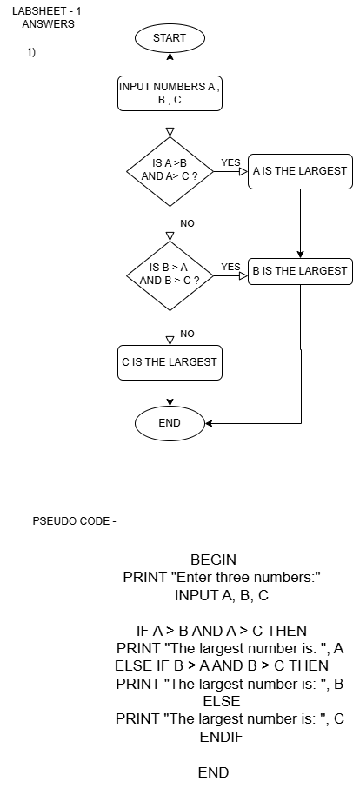

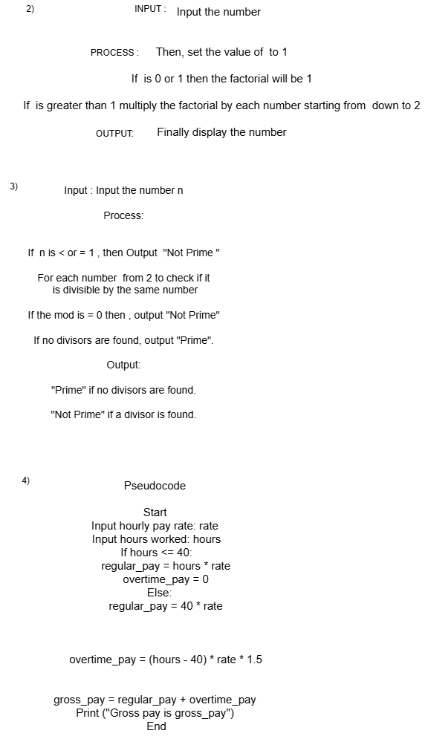

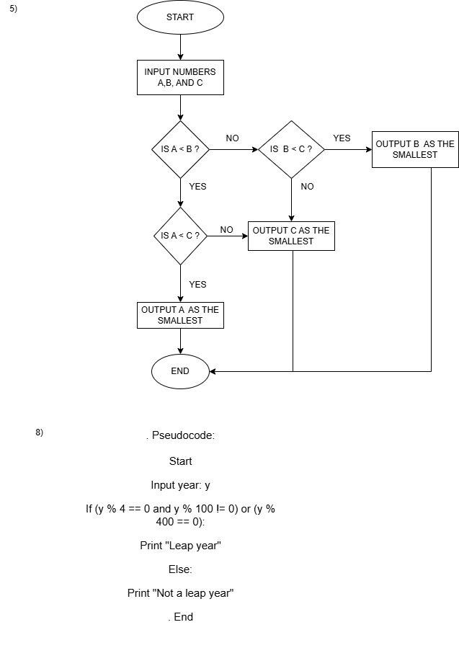

**6) –**

**7) ----**